Faculty Senate Meeting Agenda
12 September 2023
Agile Strategy Lab (CKB L70), 11:30 AM–1:30 PM

- Convening of the Meeting – Daniel E. Bunker, President
- Approval of Minutes of the Faculty Senate meeting on May 9, 2023
- Report of the Faculty Senate President
  - Introduction of new Faculty Senators
  - Expectations for Faculty Senators
    - Attend all meetings of the Faculty Senate committees to which they are appointed, and participate fully and knowledgably in the deliberations of the Faculty Senate and their assigned committees.
    - Keep their academic units informed of Faculty Senate business and decisions.
    - Solicit the opinions of other faculty and instructional staff in their academic units about Faculty Senate business.
    - Represent the academic interests of the faculty and university as a whole, as well as the interests of their own academic units.
    - Decorum
  - New Faculty Orientation
  - YWCC Dean search is underway
  - Evaluation of Administrators
  - Egypt update
  - Teaching Professor Ranks

  - Department Bylaws
    - From the Faculty Handbook: “Each Department shall either adopt the Default Department Bylaws or adopt customized Department Bylaws of its own construction which conform to the format of the Default Department Bylaws.”
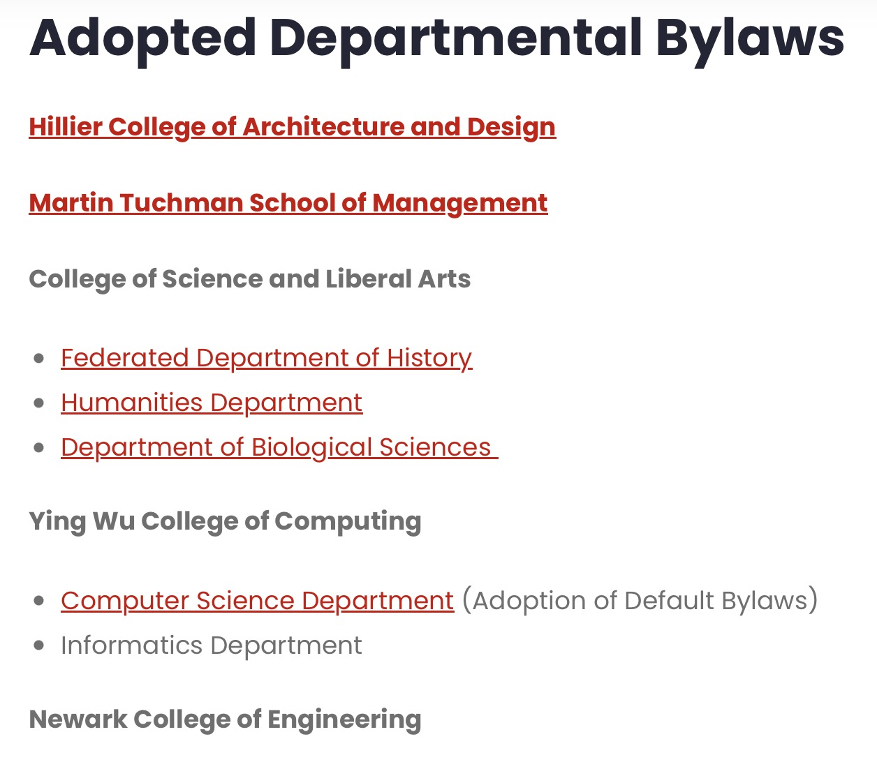
  - University P&T Committee nominees and composition
  - Faculty Search and Selection Guidelines
  - FS representative needed for the Committee on Research, Scholarship and Creative Academic Activity
- Welcome Provost Pelesko
- FS Vice President Election
- FS Executive Committee elections
- New Business

