ABSTRACT

TITLE

by
FirstName LastName
Text of paragraph one.
Text of paragraph two. Note the indent.

TITLE

by
FirstName LastName

A Dissertation
Submitted to the Faculty of
New Jersey Institute of Technology
In Partial Fulfillment of the Requirements for the Degree of
Doctor of Philosophy in Program

Department

Graduation Date (either January, May or August + year)

Copyright © Year by FirstName LastName
ALL RIGHTS RESERVED

APPROVAL PAGE

TITLE
FirstName LastName

Name, Dissertation Advisor Date
Title, College or Place of Employment

Name, Committee Member Date
Title, College or Place of Employment

Name, Committee Member Date Title, College or Place of Employment

Name, Committee Member Date
Title, College or Place of Employment

Name, Committee Member Date
Title, College or Place of Employment

BIOGRAPHICAL SKETCH

Author: FirstName LastName
Degree: Master of Science / Doctor of Philosophy
Date: Month and Year (you are graduating)
Date of Birth: Month, Day, Year (For e.g., November 3, 1992)
Place of Birth: City, State, Country (if outside US)
Undergraduate and Graduate Education:
- Most recent education experience goes here

- The further down you go, the older the education experience - for example, a Master's would go above your Bachelor's degree

- Entries include degree, university, location of university, and year awarded

Example:
- Doctor of Philosophy in Computer Science,
New Jersey Institute of Technology, Newark, New Jersey 2024

Major: Your major / program (Indicate your current program)
Presentations and Publications:
- Most recent publication goes first.

- The further down you go, the older the presentations - for example, a 2018 presentation would go above a presentation from 2015.

- This section may be excluded if you do not have any relevant presentations or publications.

- You can list in preparation, submitted, under review publications.

< Write personal dedication in Italics >
< Samples are available for viewing in the Office of Graduate Studies >

ACKNOWLEDGMENTS

The first paragraph of this section is dedicated to the Thesis or Dissertation Advisor.
The second paragraph is indented and dedicated to Committee members.
The third paragraph is indented and dedicated to Funding source(s) and Technical support.
Subsequent paragraphs are indented and may include peers who were key to the student's success.
Some also finish with family members.

TABLE OF CONTENTS

Chapter Page
- INTRODUCTION 1
1.1 Objective 1
1.1.1 Title of Subsection 1 1
- APPENDIX A (Optional) 4
- APPENDIX B (Optional) 5
- REFERENCES 6

TABLE OF CONTENTS
(Continued)

Chapter Page
- INTRODUCTION 25
5.1 Objective 25
5.1.1 Title of Subsection 1 28
- APPENDIX A (Optional) 44
- APPENDIX B (Optional) 45
- REFERENCES 46

 | LIST OF TABLES
Table | Page
x.1 |  | Signal Model (Capitalize Each Word) …………………………………… |  | x
x.2 |  | Space-Time Combining Schemes ……………………….………………. |  | xx

 | LIST OF FIGURES
Figure |  |  | Page
x.1 |  | Performance of ST receiver as a function of number of ratio q ………….. |  | x
x.2 |  | The average BER vs. the average received SNR with on interference …... |  | xx

LIST OF SYMBOLS (Optional)

© |  | Copyright
∫ |  | Integration
Å |  | Angstrom (10-10 meters)

LIST OF DEFINITIONS (Optional)

Accuracy | How closely an instrument measures the true or actual value of the process variable being measured or sensed.
Acidic | The condition of water or soil which contains a sufficient amount of acid substances to lower the pH below 7.0.
Alkaline | The condition of water or soil which contains a sufficient amount of alkali substances to raise the pH above 7.0.
Effective range | That portion of the design range (usually upper 90 percent) in which an instrument has acceptable accuracy.

CHAPTER 1

INTRODUCTION

Objective
The objective of this dissertation is to present applications of space-time processing for the following multiple-access, wireless communication systems: time-division division multiple-Access (TDMA) and code division multiple-access (CDMA). For the TDMA system, the following spatial processing techniques: optimum combining and direct matrix inverse (DMI) were reviewed; and eigen analysis-based processing, or the eigen canceler was proposed.
For the CDMA system, the following receiver consecrations are formulated and compared: (1) space-time maximum ratio combining (SMRC/TMRC) (in effect spacetime diversity), (2) cascade optimum space-MRC time (SOPT/TMRC) (optimum spatial processing cascaded with a RAKE receiver) and (3) cascade optimum space-optimum time (SOPT/TOPT).

Title of Subsection 1
In recent years new adaptive algorithms have been suggested for subspace tracking (Patel, 1998), (Valdez, 1999). Let r be the rank of the interference subspace. Then, the algorithm consists of the following steps:
- Initialize the interference subspace and initialize X. L is a N by r matrix defined as whatever used to be written here.

- This list is continued here to show that the space between two list points is double spaced.

- As wireless networks proliferate and the subscriber community increases, the load on the network increases.

Table X.x Title of Table 1 (Capitalize Each Word in the Title)
Table x.1 | Filler Text | Filler Text | Filler Text
x | x | x | x
x | x | x | x
x | x | x | x
x | x | x | x
Source: Source of table X.x (Must be in 10 points)

A qualitative picture of the longitudinal electric field at the axis of the electron avalanche is given in Figure 16.7. The x=0 plane corresponds to the front of the avalanche and is where the field attains the maximum average value it can have in the gap-Em. Away from this plane, the electric field decreases. Notice that for x>0, the fields decrease is slower than for x<0.

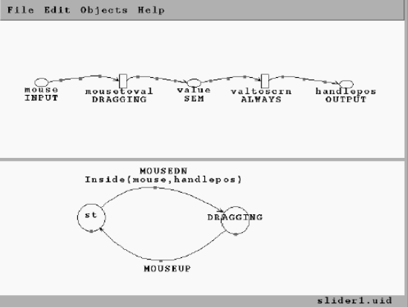
Figure X.x Description of the figure (Description begins with a capital letter, followed by sentence case. Acronyms, and proper names are capitalized, and always ends with a period.)
Source: Source of figure X.x (Must be in 10 points)

Figure X.x shows the specification of this simple slider in our visual notation, running on our graphical editor, VRED. The upper portion of the screen shows the continuous portion of the specification using ovals to represent variables, rectangles for links, and arrows for data flows. The name of each link is shown under its rectangle.

E = mc² (1.1)

Understanding the area of a circle is essential in various fields, including mathematics, engineering, architecture, and physics. It is used in the calculation of surface areas, volumes, and in solving real-world problems involving circular shapes, such as calculating the area of a circular garden, the surface area of a cylindrical container, or the area of a circular piece of land.

APPENDIX A (Optional)
SAMPLING SITES

Figures A.1 to A.12 show sampling locations at YPG and APG sites.
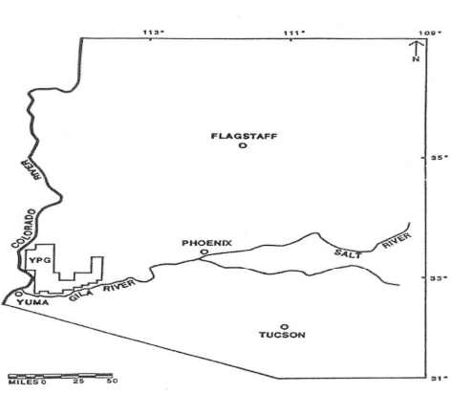
Figure A.1 Regional Map Depicting Yuma Proving Ground (U.S. Army YPG, 1999).
Source: Source of figure X.x (Must be in 10 points)

APPENDIX B (Optional)
PARAMETER SENSITIVITY ANALYSIS RESULTS

Parameter sensitivity analysis results for each receptor in both APG and YPG sites are
provided in the following Tables.
Table B.1 Sensitivity Analysis, Terrestrial Animals, APG
Table x.1 | Filler Text | Filler Text | Filler Text
x | x | x | x
x | x | x | x
x | x | x | x
x | x | x | x
Source: Source of table X.x (Must be in 10 points)

REFERENCES

Bork, B.E., Cook, T.M., & Rosencrance, J.C. (1996). Work-related musculoskeletal
disorders among physical therapists. Physical Therapy, 76, 827-835.

Bureau of Labor and Statistics (2000). Number and percent of nonfatal occupational
injuries and illnesses involving days away from work for the ten occupations with
the largest number of cases by case and worker characteristics. Retrieved October 28, 2003, from http://www.bls.gov/iif/oshwc/osh/case/ostb1023.pdf.

Chaffin, D. & Andersson, G.B.J, & Marrtin, B.J. (1993). Occupational Biomechanics (3rd
ed.). New York: John Wiley and Sons, Inc. (pp.182-252).

De Looze, M., Zinezen E., Caboor, D., Roy, P., & Claris, J. (1998). Muscle Strength, task
performance and low back load in nurses. Ergonomics, 41, 1095-1104.

(OR)

- Nelkin, D., and M. Pollack. 1980. Problems and procedures in the regulation of
technological risk. In R. Schwing and W. Albers (eds.), Societal risk management. p. 136-67. Plenum Press, New York.

- National Research Council. 1977. World food and nutrition study: the potential
contributions of research. Author, Washington, D.C.

- Office of Technology Assessment, U.S. Congress. 1980. Energy for biological
processes, vol. 2. Technical analysis. U.S. Government Printing Office, Washington, D.C.

