CHAPTER 1 INTRODUCTION

Objective

The objective of this dissertation is to present applications of space-time processing for the following multiple-access, wireless communication systems: time-division division multiple-Access (TDMA) and code division multiple-access (CDMA)
For the TDMA system, the following spatial processing techniques: optimum combining and direct matrix inverse (DMI) were reviewed; and eigenanalysis-based processing, or the eigencanceler was proposed. An analysis of system performance shows that the eigencanceler is superior to DMI when small data sets are available.
For the CDMA system, the following receiver consecrations are formulated and compared: (1) space-time maximum ratio combining (SMRC/TMRC) (in effect space- time diversity), (2) cascade optimum space-MRC time (SOPT/TMRC) (optimum spatial processing cascaded with a RAKE receiver) and (3) cascade optimum space-optimum time (SOPT/TOPT).

Background Information

Wireless communication offers universal network access by removing users' location and time constraints. As wireless networks proliferate and the subscriber community increases, the load on the network increases. The tremendous growth in network bandwidth has driven the convergence of voice, video, and data to IP based networks.

The bandwidth available on wired networks is increasing by a factor of 10 every two years. Wireless bandwidth is doubling every 9 months. Technologies such as Gigabit Ethernet, Wireless IP, and Bluetooth are making bandwidth more abundant and inexpensive. Meanwhile, computer processing speed, memory, and disk space doubles every 18 months. Simultaneously, the size of computing platforms continues to decrease. Today’s handheld PCs are often more powerful than desktop computers of the 90s. Once a rare commodity, computers are now embedded in everything - toys, cars, cell phones, even bread makers.

CHAPTER 3 IMPLEMENTATION

In Chapter 2, spatial processing techniques mainly for block processing were presented. Block processing for both optimum combining and the eigencanceler require O(N3) flops per data block. Adaptive algorithms provide continuous tracking and have lower computational requirements. The LMS and RLS are two common algorithms used to implement optimum combining.

3.1 Adaptive Algorithms for the Eigencanceler

Traditionally, decomposition of the signal space has been achieved using either eigenvalue decomposition (EVD) or singular value decomposition (SVD). The full decompositions, however, are computationally inefficient, requiring O(N3) flops and

hence, they are not suited for real-data applications. In recent years new adaptive algorithms have been suggested for subspace tracking (Patel, 1998), (Valdez, 1999).

3.1.1 Projection Algorithm

Let r be the rank of the interference subspace. Then, the algorithm consists of the following steps:
- Initialize the interference subspace and initialize X. L is a N by r matrix defined as whatever used to be written here.
- This list is continued here to show that the space between two list points is double spaced.
- This is the last point of this list.

Table 5.6 Diffusion Coefficients and Molecular Diameters of Non-electrolytes

Molecular Weight
g/(g-mol)

Diffusivity in Solution
10-5 *(cm2 /s)

Molecular Diameter
10-8 * cm

10 | 2.20 | 2.9
100 | 0.70 | 6.2
1,000 | 0.25 | 13.2
10,000 | 0.11 | 28.5
100,000 | 0.05 | 62.0
1,000,000 | 0.025 | 132.0
Source: W.S. Winston Ho and Norman N. Li , “Membrane Processes,” Perry’s Chemical Engineers’ Handbook, ed. Robert H. Perry and Don W. Green, 6th ed. (New York: McGraw-Hill, 1984)17-20.

A qualitative picture of the longitudinal electric field at the axis of the electron avalanche is given in Figure 16.7. The x=0 plane corresponds to the front of the avalanche and is where the field attains the maximum average value it can have in the

.
gap-Em. Away from this plane, the electric field decreases. Notice that for x>0, the fields decrease is slower than for x<0.

E=MC2 (1.1)

The electron energy distribution is far from equilibrium. It is enriched with high – energy electrons, a consequence of the large electric field. Furthermore, the distribution is anisotropic in the high energy.

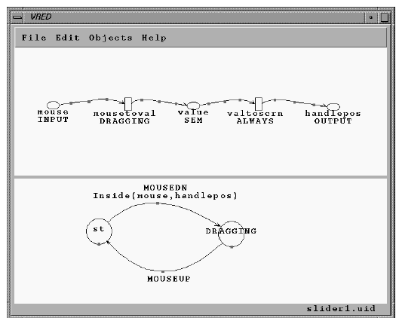

Figure 5.1 Specification of a simple slider, running in the VRED editor, to illustrate our graphical notation. The upper half of the screen shows the continuous portion of the specification, using ovals to represent variables, rectangles for links, and arrows for data flows. The lower portion shows the event handler in the form of a state diagram, with states represented as circles and transitions as arrows.
Source: Robert J. K. Jacob, Leonidas Deligiannidis, and Stephen Morrison “A Software Model and Specification Language for Non-WIMP User Interfaces” Tufts University, ACM Transactions on Computer-Human Interaction, Vol. 6, No. 1, March 1999, pp. 1–46.
http://www.postech.ac.kr/~gkim/cse511/p1-jacob.pdf, accessed February 9, 2009.

Figure 5.1 shows the specification of this simple slider in our visual notation, running on our graphical editor, VRED. The upper portion of the screen shows the continuous portion of the specification using ovals to represent variables, rectangles for links, and arrows for data flows. The name of each link is shown under its rectangle.
On the next page is Figure 5.2 which requires landscape format. It shows the conceptual model for offshore software development in which the three project performance measures—effort, elapsed time, and rework—appear as three ovals. It is postulated that as rework increases, both elapsed time and project effort increase.

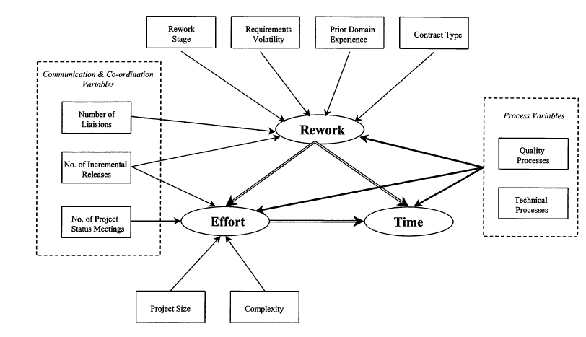Figure 5.2 Conceptual model for offshore software development in which the three project performance measures—effort, elapsed time, and rework—appear as three ovals.
Communication and Co-ordination Variables
Number of Liaisons
43
Source: Anandasivam Gopal, Tridas Mukhopadhyay, and Mayuram S. Krishnan “The Role of Software Processes and Communication in Offshore Software Development” COMMUNICATIONS OF THE ACM April 2002/Vol. 45, No. 4ve, pp. 193-200. http://www.rhsmith.umd.edu/faculty/agopal/Offshore%20CACM%20Final.pdf accessed February 9, 2009.

